


Apply catering control principles and procedures
D1.HCC.CL2.01
Trainee Manual






Apply catering control principles and procedures

D1.HCC.CL2.01

Trainee Manual




Project Base
William Angliss Institute of TAFE
555 La Trobe Street
Melbourne 3000 Victoria
Telephone: | (03) 9606 2111
Facsimile: | (03) 9670 1330
Acknowledgements
Project Director: | Wayne Crosbie
Chief Writer: | Alan Hickman
Subject Writer: | Garry Blackburn
Project Manager: | Alan Maguire
Editor: | Jim Irwin
DTP/Production: | Daniel Chee, Mai Vu, Kaly Quach

The Association of Southeast Asian Nations (ASEAN) was established on 8 August 1967. The Member States of the Association are Brunei Darussalam, Cambodia, Indonesia, Lao PDR, Malaysia, Myanmar, Philippines, Singapore, Thailand and Viet Nam.
The ASEAN Secretariat is based in Jakarta, Indonesia.
General Information on ASEAN appears online at the ASEAN Website: www.asean.org.
All text is produced by William Angliss Institute of TAFE for the ASEAN Project on “Toolbox Development for Front Office, Food and Beverage Services and Food Production Divisions”.
This publication is supported by the Australian Government’s aid program through the ASEAN-Australia Development Cooperation Program Phase II (AADCP II).
Copyright: Association of Southeast Asian Nations (ASEAN) 2013.
All rights reserved.
Disclaimer
Every effort has been made to ensure that this publication is free from errors or omissions. However, you should conduct your own enquiries and seek professional advice before relying on any fact, statement or matter contained in this book. The ASEAN Secretariat and William Angliss Institute of TAFE are not responsible for any injury, loss or damage as a result of material included or omitted from this course. Information in this module is current at the time of publication. Time of publication is indicated in the date stamp at the bottom of each page.
Some images appearing in this resource have been purchased from stock photography suppliers Shutterstock and iStockphoto and other third party copyright owners and as such are non-transferable and non-exclusive. Clip arts, font images and illustrations used are from the Microsoft Office Clip Art and Media Library. Some images have been provided by and are the property of William Angliss Institute.
Additional images have been sourced from Flickr and SKC and are used under Creative Commons licence: http://creativecommons.org/licenses/by/2.0/deed.en
File name: TM_Apply_catering_control_prin_&_proc_FN_020214





Table of Contents
Introduction to trainee manual 1
Unit descriptor 3
Assessment matrix 5
Glossary 7
Element 1: Apply catering control principles and procedures 9
Element 2: Minimise wastage 37
Presentation of written work 43
Recommended reading 45
Trainee evaluation sheet 47
Trainee Self-Assessment Checklist 49

Introduction to trainee manual

To the Trainee
Congratulations on joining this course. This Trainee Manual is one part of a ‘toolbox’ which is a resource provided to trainees, trainers and assessors to help you become competent in various areas of your work.
The ‘toolbox’ consists of three elements:
- A Trainee Manual for you to read and study at home or in class
- A Trainer Guide with Power Point slides to help your Trainer explain the content of the training material and provide class activities to help with practice
- An Assessment Manual which provides your Assessor with oral and written questions and other assessment tasks to establish whether or not you have achieved competency.
The first thing you may notice is that this training program and the information you find in the Trainee Manual seems different to the textbooks you have used previously. This is because the method of instruction and examination is different. The method used is called Competency based training (CBT) and Competency based assessment (CBA). CBT and CBA is the training and assessment system chosen by ASEAN (Association of South-East Asian Nations) to train people to work in the tourism and hospitality industry throughout all the ASEAN member states.
What is the CBT and CBA system and why has it been adopted by ASEAN?
CBT is a way of training that concentrates on what a worker can do or is required to do at work. The aim is of the training is to enable trainees to perform tasks and duties at a standard expected by employers. CBT seeks to develop the skills, knowledge and attitudes (or recognise the ones the trainee already possesses) to achieve the required competency standard. ASEAN has adopted the CBT/CBA training system as it is able to produce the type of worker that industry is looking for and this therefore increases trainees’ chances of obtaining employment.
CBA involves collecting evidence and making a judgement of the extent to which a worker can perform his/her duties at the required competency standard. Where a trainee can already demonstrate a degree of competency, either due to prior training or work experience, a process of ‘Recognition of Prior Learning’ (RPL) is available to trainees to recognise this. Please speak to your trainer about RPL if you think this applies to you.
What is a competency standard?
Competency standards are descriptions of the skills and knowledge required to perform a task or activity at the level of a required standard.
242 competency standards for the tourism and hospitality industries throughout the ASEAN region have been developed to cover all the knowledge, skills and attitudes required to work in the following occupational areas:
- Housekeeping
- Food Production
- Food and Beverage Service
- Front Office
- Travel Agencies
- Tour Operations.
All of these competency standards are available for you to look at. In fact you will find a summary of each one at the beginning of each Trainee Manual under the heading ‘Unit Descriptor’. The unit descriptor describes the content of the unit you will be studying in the Trainee Manual and provides a table of contents which are divided up into ‘Elements’ and ‘Performance Criteria”. An element is a description of one aspect of what has to be achieved in the workplace. The ‘Performance Criteria’ below each element details the level of performance that needs to be demonstrated to be declared competent.
There are other components of the competency standard:
- Unit Title: statement about what is to be done in the workplace
- Unit Number: unique number identifying the particular competency
- Nominal hours: number of classroom or practical hours usually needed to complete the competency. We call them ‘nominal’ hours because they can vary e.g. sometimes it will take an individual less time to complete a unit of competency because he/she has prior knowledge or work experience in that area.
The final heading you will see before you start reading the Trainee Manual is the ‘Assessment Matrix’. Competency based assessment requires trainees to be assessed in at least 2 – 3 different ways, one of which must be practical. This section outlines three ways assessment can be carried out and includes work projects, written questions and oral questions. The matrix is designed to show you which performance criteria will be assessed and how they will be assessed. Your trainer and/or assessor may also use other assessment methods including ‘Observation Checklist’ and ‘Third Party Statement’. An observation checklist is a way of recording how you perform at work and a third party statement is a statement by a supervisor or employer about the degree of competence they believe you have achieved. This can be based on observing your workplace performance, inspecting your work or gaining feedback from fellow workers.
Your trainer and/or assessor may use other methods to assess you such as:
- Journals
- Oral presentations
- Role plays
- Log books
- Group projects
- Practical demonstrations.
Remember your trainer is there to help you succeed and become competent. Please feel free to ask him or her for more explanation of what you have just read and of what is expected from you and best wishes for your future studies and future career in tourism and hospitality.

Unit descriptor
Apply catering control principles and procedures
This unit deals with the skills and knowledge required to Apply catering control principles and procedures in a range of settings within the hotel and travel industries workplace context.
Unit Code:
D1.HCC.CL2.01
Nominal Hours:
15

Element 1: Apply catering control principles and procedures
Performance Criteria
1.1 Identify the range of catering products used within the enterprise
1.2 Use requisition/portion control effectively
1.3 Use standard recipes correctly
1.4 Implement ordering and stock rotation practices
1.5 Use optimum storage conditions

Element 2: Minimise wastage
Performance Criteria
2.1 Use trimmings of food products
2.2 Dispose of food wastage in line with enterprise and local authorities’ requirements
2.3 Process recyclable products to local authority requirements

Assessment matrix
Showing mapping of Performance Criteria against Work Projects, Written Questions and Oral Questions
The Assessment Matrix indicates three of the most common assessment activities your Assessor may use to assess your understanding of the content of this manual and your performance – Work Projects, Written Questions and Oral Questions. It also indicates where you can find the subject content related to these assessment activities in the Trainee Manual (i.e. under which element or performance criteria). As explained in the Introduction, however, the assessors are free to choose which assessment activities are most suitable to best capture evidence of competency as they deem appropriate for individual students.
 |  |  | Work Projects | Written Questions | Oral Questions
Element 1: Apply catering control principles and procedures
1.1 | Identify the range of catering products used within the enterprise |  | 1.1 | 1, 2 | 1
1.2 | Use requisition/portion control effectively |  | 1.2 | 3, 4, 5, 6 | 2
1.3 | Use standard recipes correctly |  | 1.2 | 7, 8, | 3
1.4 | Implement ordering and stock rotation practices |  | 1.3 | 9, 10, 11, 12, 13, 14, 15 | 4
1.5 | Use optimum storage conditions |  | 1.3 | 16, 17, 18 | 5
Element 2: Minimise wastage
2.1 |  | Use trimmings of food products | 2.1 | 19, 20 | 6
2.2 |  | Dispose of food wastage in line with enterprise and local authorities’ requirements | 2.2 | 21, 22 | 7
2.3 |  | Process recyclable products to local authority requirements | 2.2 | 23, 24 | 8

Glossary
Term | Explanation
Catering Control | Controlling the process of catering by controlling process
Code of Practice | A set of regulations by which to operate
Compliance | Conforming the requirements of law or regulation
Cost Control | Determining all the cost and applying it to income
Fraud | Fraud is intentional deception for personal gain.
Portion Control | A standard recipe will yield a set number of serves; portion control requires that number of serves to be attained
Recycling | Reusing waste products like food scraps and packaging so it does not become burden on society
Resources | All products that are required to operate a catering business
Standard Recipe | List of ingredients and methods of cooking to produce a set quantity of food at a specific standard
Stock | Products required to produce menu items
Stock control | Controlling from the amount of stock on hand at anytime within the enterprise
Trimmings | When product is cut to size the excess becomes trimmings; good to utilise in another dish

Element 1:
Apply catering control principles and procedures

1.1 Identify the range of catering products used within the enterprise


Introduction
Range of catering products may include:
- Perishable products, including fruit, vegetables, meat, seafood
- Paper goods, such as wrapping, boxes, gift ware
- Chemicals
- Glass
- Plastic products, such as disposable cups, plates, cutlery
- Foam products, such as fast food packaging.
An important aspect of integrating environmentally sustainable work practices into your work is to recognise and understand the actual resources you use on a day-to-day basis.
What are the resources?
Most texts will identify three types of resources used by a business – human, natural and financial.
In this unit we are concerned primarily with natural resources but we must also be aware of the impact of the physical resources we use too (such as food and beverages, and other stock and equipment we might purchase) when considering environmentally sustainable practices in the broadest context.
The resources used by individuals will vary with their job role but in a hospitality and tourism context they will commonly include:
- Food
- Beverages
- Plant and equipment – fax machines and printers, computers, ovens and cooking appliances
- General stock – which can include linen, chemicals, stationery, furniture and fittings
- Energy – gas, electricity
- Water.
Certain tourism-oriented properties will also add ‘the natural environment’ (land, flora and fauna) to this list.
We must also include in our consideration of ‘resources’ from an environmental perspective:
- The impact our operation has on air quality
- Noise pollution
- The waste generated by the business and how that waste can be minimised and most effectively disposed of.
Possible alternatives
While in everyday activities you will only be able to work with the resources provided for you by management, this awareness should highlight the need (into the future) to consider:

- Alternative sources of energy – including solar, wind power, geothermal, tidal, hydroelectric, biomass (from wood, waste or alcohol): this will enable the business to reduce its impact on the environment and it should be a common goal amongst all operators to optimise the use of ‘renewable’ energy sources
- By definition, a renewable energy source is one that can be replaced or replenished quicker than it is used thereby making it truly sustainable
- By contrast, ‘green energy’ is energy produced from any source that is non-polluting, and therefore environmentally friendly
- Green purchasing – buying products that are made (and transported) in an environmentally sensitive manner
- Applying one or more aspects of the Waste Management Hierarchy – in practice this means analysing and evaluating the use of all resources with a view to:
- Reducing the quantity of resources used wherever possible – which may include the use of more efficient equipment; the reformulation of recipes and standard practice, such as replacing bed linen on a less frequent basis, using energy efficient light globes and reducing temperature of water heaters
- Reusing – by ensuring all food that can be safely used (such as off-cuts and trimmings) is used rather than thrown out; by replacing single use items (such as paper serviettes, plastic cutlery) with reusable products; by straining and reusing cooking oil from deep fat fryers; by reusing ‘grey water’ (see below) to water plants, lawns and external areas
- Recycling – ensuring all materials that can be recycled are appropriately recycled; by focusing purchases on materials which can be recycled with special consideration given to ‘recyclable packaging’ (see below); recycling leftovers where legal and safe to do so; by refilling printer cartridges; by using only recycled paper in the business .

Grey water
Grey water is water that has already been used for washing, laundry or bathing purposes which is reused. The use of grey water saves the use of drinking water for non-drinking purposes. Water from toilets cannot be reused because of faecal contamination) and water from kitchen cannot be used because of the potential for food scraps and chemicals which may not break down.
Recyclable packaging
‘Waste Wise Toolkit: small changes, big differences’ (pp 31-32), states that recycling packaging: is packaging that is currently commercially recycled.
This varies across countries but the Australian states and territories; however a few simple principles apply:
Plastics – it’s as simple as:
- Code 1: PET, (e.g. Soft drink bottles and fruit juice bottles, cups + carry trays)
- Code 2: HDPE (e.g. Milk, cream and juice bottles)
- Code 3: V (e.g. Juice and cordial bottles)
It is currently only economically viable to recycle three types of plastic from domestic sources, but changes are being made all the time.
The food service industry causes a large waste disposal problem.
Other alternatives to disposables
- Paper plates and bowls – food waste (organics)
- Steel and aluminium – recycle
- Corn starch cutlery – food waste (organics)
- PET cups and carry trays – recycle.
Note: Ask your waste contractors to keep you informed of any changes.
What is not (generally) recyclable packaging?
Check with your local government or waste contractor if there might be local opportunities to recycle the following:
- Plastics with 4, 5, 6, 7
- Waxed cardboard
- Polystyrene boxes
- Polystyrene cups
- Plastic straws
- Plastic bags.

1.2 Use requisition/portion control effectively

Portion Control
Portion control is to control the quantity of food served to each customer.
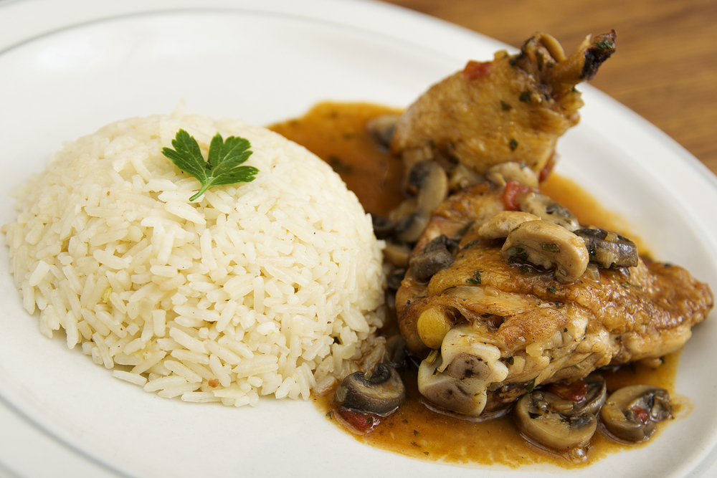
Why?
- To know how much food to order
- To know what yield is obtained from each food item
- Helps to calculate the cost of each dish on a menu therefore its selling price
- To ensure each customer receives a meal that is uniform in quantity and standard.
Portion sizes can be determined by:
- Number of courses to be served
- Size and design of crockery
- Type of customer
- Menu pricing structure.
Portion sizes can be controlled by:
- Buying food of specific portion size
- Training staff on how to control portions and why it is important
- Using appropriate utensils, equipment and measures to serve food
- Supervising staff during service.

Portion Sizes
Portion sizes will be a debatable point all the time.
Generally speaking the more expensive the meals the smaller the portion sizes.
This might sound strange but the more expensive the menu item the better quality;
- Finer breeding in the animals
- Hand raised cattle are more expensive than range fed
- Limited number available
- Popularity may make it hard to obtain so the price will be higher
- Seafood tends to be more expensive when stocks are low.
Below is an average size used in good quality restaurants:
Meat, Fish and Poultry
- 150g in pastry or similar
- 180g pure meat i.e. fillet steak
- 200g sirloin, rump
- 250 – 300g T-bone, whole trout, flounder.
Vegetables
- Two serves of at least 50g each
- Used to be meat, 2 vegetables plus a farinaceous item.
Farinaceous
- Potato, pasta, rice, lentils
- 100g for a main meal
- 30 – 75g for an entrée.
Shellfish
60- 90g per entree portion depending on how rich the overall dish is and what else is served with it.
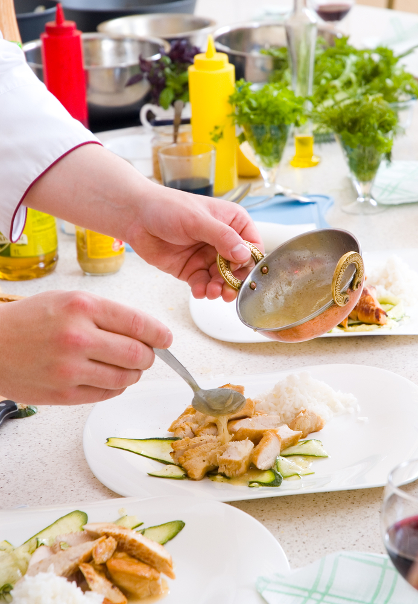
Soup
200 - 250ml per entree portion.
Sauce
20 - 50ml per portion depends on the richness of the sauce.
Portion control can be by size and not weight.
The more slices the more profit. But will the customers be happy with the serving size.
Customers expect a large slice of cake but most of the time they cannot finish the cake because the serving size is too large.
But if you charged them the same price for a smaller piece they will think it is too expensive for what they are paying.
Cakes
- 20 cm: 8 – 10 portions
- 25 cm: 12 portions
- 30 cm: 16 portions.
(All of the above depend on the thickness and richness of the cake)
To obtain good portion control the chef/cook needs to know the yields for various raw and processed products they work with, therefore it is important to make a habit of regularly counting, measuring and weighing food products in the Kitchen when working with them.
For example:
- How many dry biscuits are in a packet?
- Slices of bread in a normal sliced loaf
- How many apricots halves in a tin weighing 445g?

Portion control exercises
- I need 55 portions of fish fillets weighing 120g each. How much fish do I need to purchase?

- How much smoked salmon do I need to buy for a function of 550 people, giving 3 slices per person when each slice weighs 45g?

- I bought 2 turned potatoes per person for a function of 45 people. What is the portion size, and how much did I need to buy?

- I bought a 2.5kg tub of semi-dried tomatoes. Giving 20g per person, how many portions are there?

- A 3.250 kg cooked, boned leg of lamb will yield how many portions of 175 g?

- You need to cook 85 portions of rice for a buffet. How much raw weight of rice do I need to cook?

- How many black forest cakes (25 cm) do I need to buy for a function of 120 people?

- How many 180 gm sirloin steaks will be acquired from a trimmed 3.42kg sirloin?

1.3 Use standard recipes correctly

Introduction
A standard recipe is a precise record of ingredients, method, serving instructions and cost of any food item on a menu.
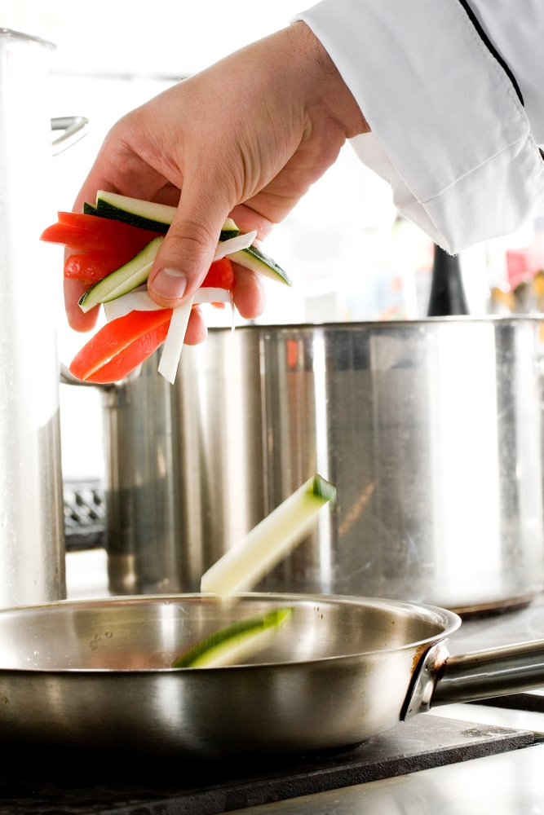
A standard recipe needs to include:
- Summary of ingredients
- Required quantities or each item
- Specific preparation guidelines
- Garnish and service details
- Portion sizes
- Accurate costs
- % wastage
- Date.
Why do we use them?
- Standardise production of recipes -regardless of who makes them
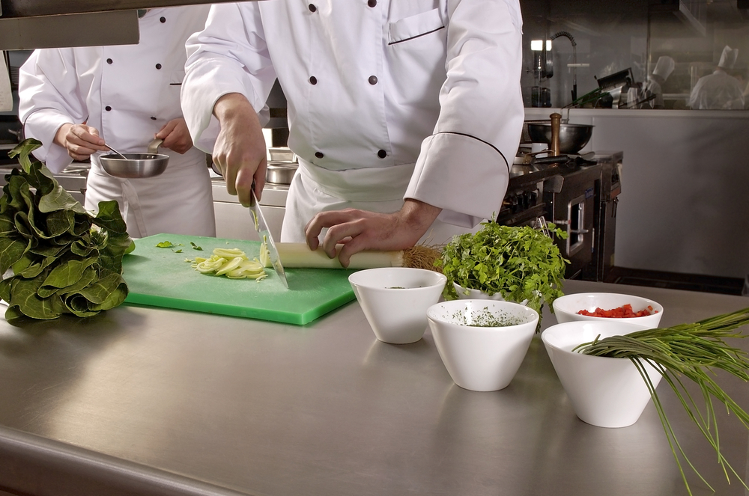
- Consistent quality – always taste the same
- Consistent presentation – always look the same
- Consistent portion size - always the same quantity
- Easy to calculate cost of dish – and re-establish cost of dish
- Customer satisfaction.

To calculate cost of purchase amount
FORMULA
Cost per Unit ÷ Unit x Purchase Amount = Cost of purchase amount.
Example:
Commodity Cost Unit Amount used Cost of usage
Apples $2.99kg ÷ 1000g x 255 g = $0.76
Balsamic Vinegar $2.38 ÷ 375ml x 125ml = $0.79
Basil $2.00 ÷ 1 each x .5 = $1.00
Alternative
Apples - $2.99kg x .255 = $0.76 per 255 grams
When pricing any ingredient it is important to reduce to a common denominator.
- Cost per each
- Cost per kilo or litre
- Cost per gram.
At what point should the cost be applied?
- Purchased weight
- Cleaned and prepared waste.
The purchased weight is the easiest but exactly how much are you using when it has been cleaned.
Example:
- Eggs by the each. If an egg white is needed then the full cost of one egg is used
- If the egg white is used to make meringue the full cost is applied to the recipe.
By implementing the full charge to both is a way of cost cutting and getting a better return on one egg.
In recipes eggs are best measured by weight as opposed to by each.
Eggs differ in size.
By the each is just an easier way to measure when working in small amounts.
Student Activity
There is a menu on the following page and that is followed be standard recipe sheets for each recipe.
Students are required to find local cost of each ingredient and apply to the recipe and determine the cost of the recipe and the cost of a single portion.

ENTRÉE

Spaghetti Carbonara
Garlic Prawns

MAIN COURSE

Salmon Cutlet on Mash Potato
Roast Chicken with Roast Vegetables
Sirloin Steak with Garlic Butter and French Fries

DESSERT

Fresh Fruit Salad
Mississippi Mud Cake with King Island Cream

Standard Recipe Costing
Recipe | Spaghetti Carbonara
Number of Portions 10 |  |  |  | Portion size: 150g
Ingredient | Amount | Unit | Waste  % | Useable | Purchase Amount |  | Cost per Unit | Cost of  purchase  Amount
Butter | 80g
Onion, diced | 100g
Bacon, lardons | 150g
Pepper, cracked black | 5g
Cream | 300ml
Spaghetti, cooked | 800g
Egg yolks | 10ea
Chives | .5 bch
Parmesan cheese | 200g
Total Cost
Cost per individual Portion
Selling Price @ 28% f.c.
Method of production, cooking temperatures and plating procedures
Boil Spaghetti, blanch and reserve in 80gm portions
Oven roast bacon until slightly crispy, drain from fat and reserve
Sweat onions in oil and cool until required
To serve:
Portion of butter (8g) into hot pan and add sweated onions (10g)
Add bacon lardons (15g) to pan along with pepper followed by cream and bring to boil
Re heat portion of cooked spaghetti in hot water, drain off excess water. add to boiled cream mixture and mix through
Remove from heat and add egg yolk and immediately mix through hot sauce to thicken
Add chives and place into warmed plate
Garnish with parmesan cheese
Tested and Approved by: |  |  |  |  |  | Date

Standard Recipe Costing
Recipe | Garlic Prawns
Number of Portions | 10 |  |  | Portion size: |  |  | 100g
Ingredient | Amount | Unit | Waste  % | Useable | Purchase  Amount |  | Cost  per  Unit | Cost of  purchase  Amount
Butter | 100g
Garlic, chopped | 80g
Lemons | 3 ea
Prawns, cutlets, green | 800g
Parsley, chopped | .25 bch
Total Cost
Cost per individual Portion
Selling Price @ 28% f.c.
Method of production, cooking temperatures and plating procedures
Soften the butter in bowl but do not melt
Add chopped garlic
Set garlic butter into container until required
To serve:
Place portion of garlic butter into warm pan to melt butter
Add prawns and cook gently
Add portion of lemon juices to butter and more garlic butter
Finish with chopped parsley
Place into warm plate and pour butter over prawns on plate
Tested and Approved by: |  |  |  |  |  | Date

Standard Recipe Costing
Recipe |  | Salmon Cutlet on Potato Mash with Mixed Vegetables
Number of Portions |  | 10 |  |  | Portion size: |  |  | 180g
Ingredient | Amount |  | Unit | Waste  % | Useable | Purchase  Amount |  | Cost  per  Unit | Cost of  purchase  Amount
Salmon Cutlet | 1800g
Butter | 50g
Potato | 1000g
Butter | 100g
Cream | 300g
Salt | 10g
Pepper | 5g
Peas, sugar snap | 500g
Carrots | 500g
Parsley, chopped | .25 bch
Total Cost
Cost per individual Portion
Selling Price @ 28% f.c.
Method of production, cooking temperatures and plating procedures
Peel and cut the potato into halves.
Place into cold water with salt and bring to boil
Cook until soft, drain and mash until lump free
Add butter and cream and blend through potatoes
Blanch carrots and peas then refresh in cold water
Heat pan add small nob of butter
Place cutlet onto hot pan, skin side down and cook until skin is crisp
Turn over and finish on low heat in pan, approx 2 mins
Reheat portion of mash potato in microwave
Place potato on plate in centre
Place cooked salmon cutlet on top of mash
Reheat portion of carrots and peas and place onto plate either side of cutlet
Finish with portion of melted butter poured over hot cutlet
Tested and Approved by: |  |  |  |  |  |  | Date

Standard Recipe Costing
Recipe |  | Roast Stuffed Chicken with Roast Vegetables
Number of Portions |  |  |  |  | Portion size:
Ingredient | Amount |  | Unit | Waste  % | Useable | Purchase  Amount |  | Cost  per  Unit | Cost of  purchase  Amount
Chicken (no10) | 5 ea
Egg white | 1
Onion | 100g
Rosemary | .25 bch
Oregano | .25 bch
Thyme | .25 bch
Prunes | 100g
Pinenuts | 50g
Bread crumbs fresh | 200g
Butter | 20g
Salt | 10g
Pepper | 5g
Potatoes | 1000g
Pumpkin | 500g
Zucchini | 500g
Chicken stock | 500ml
Parsley, chopped | .25 bch
Total Cost
Cost per individual Portion
Selling Price @ 28% f.c.
Method of production, cooking temperatures and plating procedures
Students to finish:
Tested and Approved by: |  |  |  |  |  |  | Date

Standard Recipe Costing 3
Recipe |  | Sirloin Steak with garlic butter and French fries
Number of Portions |  |  |  |  | Portion size:
Ingredient | Amount |  | Unit | Waste  % | Useable | Purchase  Amount |  | Cost  per  Unit | Cost of  purchase  Amount
Sirloin Steak | 2000
Vegetable oil | 60
Garlic Butter
Salt | 20
Pepper | 10
Butter | 300
Garlic | 10
Parsley | .25
Lemon | 1
French Fries
Potatoes | 1000
Frying Oil | 500
Side Salad
Salad leaves | 250
Tomatoes | 5
Cucumber | .5
Dressing
Olive oil | 200
Vinegar | 100
Salt | 5
Pepper | 3
Total Cost
Cost per individual Portion
Selling Price @ 28% f.c.
Method of production, cooking temperatures and plating procedures
Students to finish:
Tested and Approved by: |  |  |  |  |  |  | Date

Standard Recipe Costing
Recipe |  | Fresh Fruit Salad
Number of Portions |  | 10 |  |  | Portion size: |  |  | 140
Ingredient | Amount |  | Unit | Waste  % | Useable | Purchase  Amount |  | Cost  per  Unit | Cost of  purchase  Amount
Orange | 10 ea
Honeydew Melon | 2 ea
Pineapple | 2 ea
Apple | 400 g
Banana | 500 g
Kiwi fruit | 5 ea
Strawberry | 200 g
Total Cost
Cost per individual Portion
Selling Price @ 28% f.c.
Method of production, cooking temperatures and plating procedures
Students to finish:
Tested and Approved by: |  |  |  |  |  |  | Date

Standard Recipe Costing
Recipe |  | Mississippi Mud Cake with King Island Cream
Number of Portions |  | 12 |  |  | Portion size: |  |  | 90g
Ingredient | Amount |  | Unit | Waste  % | Useable | Purchase  Amount |  | Cost  per  Unit | Cost of  purchase  Amount
Mud cake 25cm | 1 ea
King Island Cream | 500 g
Raspberry,  Frozen | 500 g
Sugar, Caster | 100 g
Sugar, Icing | 80 g
Mint leaves | .25 bch
Total Cost
Cost per individual Portion
Selling Price @ 28% f.c.
Method of production, cooking temperatures and plating procedures
Students to finish method of production
Tested and Approved by: |  |  |  |  |  |  | Date

Standard Recipe Costing
Recipe
Number of Portions |  |  |  |  | Portion size:
Ingredient | Amount |  | Unit | Waste  % | Useable | Purchase  Amount | Cost  per  Unit |  | Cost of  purchase  Amount
Total Cost
Cost per individual Portion
Selling Price @ 28% f.c.
Method of production, cooking temperatures and plating procedures
Tested and Approved by: |  |  |  |  |  |  |  | Date

1.4 Implement ordering and stock rotation practices

Introduction
Two alternatives present themselves in relation to stock control systems: either a computer-based system, or a manual, paper-based one.
All employers will provide you with the necessary on-the-job training to use their particular system even though you may have had previous experience.
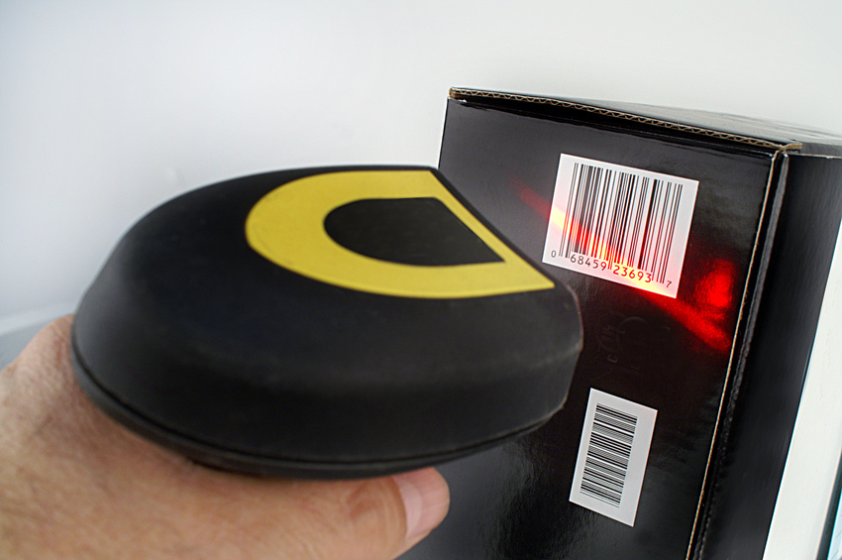
Stock control systems
In owner-operated establishments, management’s personal previous experience, industry experience and computer knowledge as well as individual preference are major factors in determining the system in use.
In large venues, and properties that are part of a chain, a computerised system is commonly used.
Computer-based system
The computerised system may cover all stock items, or only nominated articles such as liquor or linen.
Details regarding deliveries are entered into the computer to update stock-on-hand figures, and then these stock levels may be altered:
- Automatically – as point-of-sale cash registers/terminals immediately decrement (that is, reduce) the stock level when sales are made or
- Manually – as staff input data reflecting internal stock transfers from department to department, deliveries, returns etc.

Advantages of a computer-based system
Advantages of a computer-based system include:
- Quick generation of management reports – they can be produced whenever required, basically at the touch of a button
- Compact record keeping – the computer-based option takes less space than a paper-based one
- Added security – password protection provides a level of security not available with the manual system
- Enhanced levels of staff compliance with control procedures – where a computer-based stock control system is in use, staff realise all operations are monitored and analysed and tend to comply more with Standard Operating Procedures relating to stock control
- Flexibility – adding new stock and deleting old stock is quick and easy
- Automatic updates of stock levels – as items are added or decremented from stock these levels automatically adjust to represent current ‘real’ stock levels.

Disadvantages of a computer-based system
Smaller establishments may not lend themselves to using a computerised system and operators may identify the following as being negatives:
- Specialised knowledge of the computerised system or program is necessary – and they do not have adequate computer skills
- Expensive initial costs – the system may simply cost too much to introduce, and owners may not be able to justify the investment required: they may feel the money is spent better elsewhere
- Power failure and equipment breakdown can disable the system –not a common likelihood, but a negative nonetheless
- Comparatively very time-consuming to set up and maintain – new users may believe the time spent setting up such a system will take their eye off their main aim of running a hospitality property, and they maybe loathe to do this.
In addition, they may feel keeping the system up-to-date will be too time-consuming.
To many, the above reasons may sound ridiculous. But, if a person is presently running a successful operation – and has been doing so for several years – without the aid of a computer-based stock control system, it is very hard to convince them they need one.
- If the cashier is entering sales into a modern computer based system then the kitchen will be advantaged by setting up all their recipes and stock ordering on the computer.

The need to upgrade to a POS (Point Of Sale) system provides the perfect opportunity to combine a new stock system as well.

Manual system
Advantages
A perfectly acceptable and effective stock control system that has stood the test of time, the manual system is a paper-based system with the following advantages:
- It is relatively inexpensive to initiate – all you need are the basic cards, sheets, records and books
- Records are paper-based and visible – this visibility (being able to turn pages and see the figures) is very reassuring to many people: some people panic when a figure ‘disappears’ from view on a computer screen
- Access to required records does not need any specialised knowledge.


Reasons to have a stock control system
Organisations incorporate a stock control system into their business for one or more of the following reasons:
It can help to deter theft
When staff are aware that an effective stock control system is in operation, they will be less likely to steal (either money or) stock.
It can help to minimise waste
Where staff realise that an accurate record is being kept of what each department uses and the revenue they generate from the stock they use, they tend to be more careful with stock by using only what is necessary, recycling where possible and generally being more cost effective.
It helps ensure correct prices are charged
Cost prices usually increase, and to obtain the return you are entitled to, it is critical to know the full and current cost price in order to be able to calculate the desired selling price. Regularly monitoring cost prices enables correct selling prices to be set.
It helps generate information about departmental performance
Effective stock control can indicate how each and every department is performing in terms of its contribution to the overall profit of the enterprise.
It will highlight good and poor achievers as well as those on, below or above budgets and targets.
It provides the basis for many management decisions
Historical records about purchases and sales will help determine where future stock will be purchased from, how much will be bought, the level of stock to be kept on-hand, and when stock is to be purchased.

Fraud
Fraud is intentional deception for personal gain.
You must be aware from the beginning no stock control system is foolproof – staff will always work out some way around it, some way to beat it.
This applies whether the system is manual or computerised.
You must therefore always be alert to signs of fraudulent activities, and be prepared to monitor the stock system to take into account new matters arising in the workplace.
This can be:
- New staff
- New procedures
- New trading hours
- Changes to suppliers
- Alterations to target markets.
Anyone with responsibility for stock control must be alert to any signs that indicate things are ‘out of the ordinary’, and be suspicious about such events.
Suspicion may be raised by:
- A staff member is in an area where they really have no work-related business being
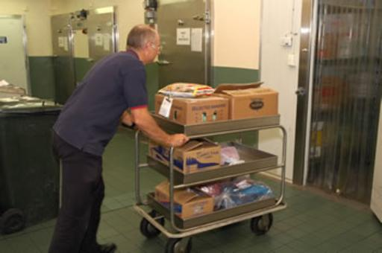
- An unusual increase in usage of a certain stock item
- An unusual increase in orders for a certain stock item
- An open carton that should be sealed
- Staff alleging an unusually high level of stock breakage
- Staff reporting an unusually high level of theft of items by guests.
Stock control, and the resultant management information it can produce, is always historical in nature – it is always a case of showing what has already occurred rather than what will happen:
- This emphasises the need for you to remain alert to signs of things which are out of the ordinary so they may be detected before the backward-looking stock take indicates there is a problem.
In relation to stock control it is definitely not a case of ‘Ignorance is bliss’.
All this means the implementation, operation and monitoring of any effective stock control system is a time-consuming undertaking demanding a large commitment in terms of time, resources and dedication.
Limits of the system
The hospitality business is somewhat different to many other enterprises in that a proportion of its stock (most food stocks as well as many of the beverages) is perishable: it has a definite use-by date beyond which it cannot be sold and hence is worthless and represents a total loss to the organisation.
Coupled with this is the unpredictability of day-to-day trade, together with the uncertainty of what guests will choose when they arrive – due, in part, to the large array of options we traditionally present them with.
Above all, a stock control system for all it can do and all the information it can provide is useless unless management uses it:
- Where the system produces results indicating something is wrong, then someone must act on the information
- They need to do some detective work to identify exactly why the problem has arisen
- Act to ensure the situation is fixed.
All the stock system will identify is that there is a problem
- It often will not indicate what the problem is, who is responsible, or what has happened.
For example, a stock control system may indicate a certain kitchen is under-performing by $200 per week.

The system will be hard-pressed to tell you exactly who is at fault,
- They may be serving larger portions unintentionally
- Dispensing in a way that results in excessive wastage
- Spilling food accidently
- They are stealing stock
- Stealing cash from the registers.
The stock control system simply flags all is not as it is expected to be.
It is then up to you to determine what is wrong and if anyone is ‘guilty’.

Stock

For the purposes of these notes, stock can be seen to include:
- Food and beverages – covering all departments, processed and unprocessed items, alcoholic and non-alcoholic stock
- Equipment – all types including maintenance, cleaning and office equipment
- Linen – including housekeeping, bar, function, and dining requirements
- Stationery – all office requisites, as well as internal documentation
- Cleaning supplies and chemicals – for use throughout the property, internally and externally
- Meal Vouchers– used for promotional purposes, staff bonus system or as part of Specials or Package deals, and to cater for groups.
Organisational requirements
The requirements regarding monitoring and maintaining stock levels will vary between properties and may vary at different times of the year.
Common organisational requirements include:
- Identification of documentation to be used to record and track stock movement and usage
- Internal protocols regarding when stock can be released from the stores area to department or individuals
- Designated maximum values of stock held on-hand – as well as identification of inventory levels for all satellite kitchens as well as main kitchen
- Nomination of stock take periods – including definition of how they should be done and who is authorised to undertake them
- Company policies regarding the introduction of new stock items into inventory
- Quality criteria for nominated products – against which all purchases must be evaluated
- Standard procedures to ensure the safety and security of stock on the premises
- Reporting requirements regarding stock – this can address reports required when stock shortage has been identified, reporting requirements following stock takes, and inventory reports identifying fast and slow moving lines, level of stock, number of stock turns etc.
Stock levels
Many properties establish limits for stock items to guide those making the purchases.
- These guidelines help ensure the overall amount of stock on the premises is not excessive.
Many premises will seek to actively manage their stock-on-hand figure and most venues will attempt to buy stock in, sell it and have the money in the bank before the stock has to be paid for. In effect, they are working on credit offered by the supplier (which is free).
These guidelines may:
- Identify the level at which an order is to be placed
- Stock can only be ordered when stock-on-hand reaches a certain level
- Set the quantity of stock to be ordered
- When an order is placed for a certain item only x can be ordered at any time.
Considerations involved regarding stock that can be ordered include historical usage, space available, the season, promotions in force or expected, and available funds or lines of credit.
In many instances, departures from these guidelines can only be made with management approval:
- Perhaps for special occasions
- When an item is available at an especially attractive price.
Other venues simply order stock as it is required, adopting a ‘Just-In-Time’ (JIT) method that orders only what is required, and gets it delivered just in time to be used, aiming – of course – to never run out.
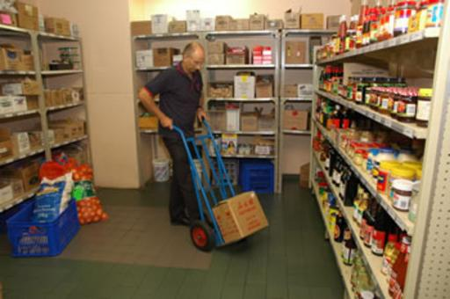
All venues should strive to never run out of items they need – once a venue gets a reputation for being a non-stockist, customers will simply go elsewhere to buy what they want.
Problematic with the JIT method is demand is difficult – if not impossible – to predict in our industry and suppliers may be unreliable in terms of their ability to deliver on time when required, especially at short notice.
Par stock levels
This term relates to the stock level for products in a store, as set by management.
The par level is the required number of each item when the store is sufficiently stocked.
When using a par stock system bar staff are required, at the end of the day, to order sufficient stock from central stores to bring levels up to the predetermined par stock level.
Commodity stock level needs to be monitored on a daily basis, if only by sight, to ensure that enough product is available for the next day or this day trading requirements.
Par stock levels are used mainly in large storage areas where several smaller venues will come to draw stock, like a large hotel where several kitchens will collect dry goods.

Storage of stock
An important factor when ordering stock is to ensure that the conditions required for storage of the stock can be managed by the establishment.
Perishable foods must be stored below 5°C.
Frozen foods must be store in an environment below minus 18°C (-18°).
Dry goods must be stored in an environment that will not be detrimental to their suitability for future human consumption, recommended 15°C-20°C.

1.5 Use optimum storage conditions
Storage in catering establishments vary greatly.
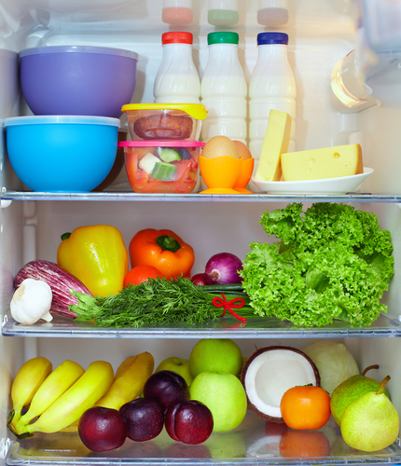
- Food
- Equipment
- Stationary.
Food storage will be based on ‘perishable’ and ‘non perishable’.
Perishable
- Fresh
- Frozen.
Non perishable
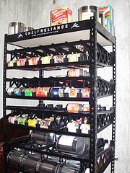
- Dry goods.
Non Food items
- Chemicals
- Equipment for kitchen
- Equipment for office
- Equipment for front of house
- Stationary
- Staff uniforms.
Food storage is the most important. Food will be stored in any of the following areas:
- Cool room
- Freezer
- Dry store.
Cool room
Cool room storage is for perishable that need to have temperature control to minimise the growth of bacteria:
- Cool room temperature requirement is less than 5°C.
Cool room is generally in close proximity to the kitchen as this is the area that will access the cool room the most.
Fresh foods will normally be held in cool room for maximum of 3-4 days.
Vacuum sealed foods can stay in cool room temperature for longer periods. See packaging for details.
Freezer
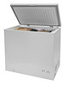
Freezers are for foods that come into the kitchen and need to be held in a frozen state until required for production purposes.
- Freezer operating temperature is minus 18 degrees Celsius (-18°C).
Freezers are also generally in close proximity to the kitchen.
Frozen foods will vary in time that it can sit in storage in freezers. The longer food is in freezer storage the more that it will cost the establishment.
Dry Storage
- Dry storage temperature is best at 15°C to 20°C.
Dry storage is for:
- Canned goods
- Dry goods like dry pasta, uncooked rice, lentils
- Perishable goods like potatoes, tomatoes will also sit in dry store for short periods of time
- Packaging goods for take away foods.
Chemical Storage
Chemicals need to be stored away from food items and items that are used for food storage.
- Chemical storage room temperature is best at 15°C - 20°C.
Chemical storage room or areas need to be well ventilated and need to have a separate waste disposal system that is not connected to the kitchen preparation area.
Many countries will have temperature much warmer than Australia. The dry store temperature listed here are the ideal temperatures or the average ambient temperature.
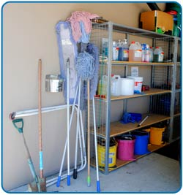
Ambient temperature is the temperature that is the air temperature without mechanical means of controlling the temperature. Air conditioning or heating.
Care must be taken with chemicals so that they are kept sealed in proper containers. Fumes from unsealed containers that are allowed to build up in confined spaces are just as dangerous as the chemical itself.
Well ventilated rooms allow for build up not to occur.
Material Data Safety Sheets (MSDS) must be visible for all people to see in chemical storage rooms.
Use safety gear as required when handling cleaning chemicals.

Work Projects
It is a requirement of this Unit you complete Work Projects as advised by your Trainer.
You must submit documentation, suitable evidence or other relevant proof of completion of the project by the agreed date to your Trainer.
Your Trainer will clarify this more but all this will be adding you’re your own database of knowledge.
The student will need to show competency in the following criteria to be deemed competent.
Students will need to complete a series of exercises that will show competency.
A report outlining the following criteria:
  - Identify a range of catering products:
- Students will need to be working with a base menu that covers a catering establishment
- All the products that will be required to produce that menu will need to be identified
- Products are not just the food
- Products required will include
  - Cleaning supplies
  - Consumables like plastic wrap, aluminium foil, paper goods that may be required
- Food handling gloves
1.2. Requisition goods required as per standard recipes.
- A list of suppliers that will be able to supply these requirements
- Students must obtain a price for each of the ingredients either for each or kilo coast
1.3. Rotation of stock implementation.
- Report on how the stock will be stored and the condition in which the stock will be stored
- List of equipment that may be required to check the stock as it is received by the catering enterprise

Summary

Apply catering control principles and procedures
Identify the range of catering products used within the enterprise
Catering products is not just the food. It includes all the other product is required to produce the food that the customers purchase.
Cleaning chemicals
Paper goods
Plastics
Glassware
Stationary.
Each enterprise will be slightly different but all commodities required need to be identified and accounted for in the cost of production and operating expenses.
Use requisition/portion control effectively
All goods and equipment needs to be requisitioned and costed to a specific department.
Control of food ordering needs to be in place to ensure that food is handled correctly and that it goes to the correct area where it will be used effectively.
Use standard recipes correctly
When producing it is important to use the correct amount of ingredient so that the correct portion size can be implemented to satisfy the customer that they are getting value for money and the enterprise is making sufficient profit to enable it to continue to operate.
Implement ordering and stock rotation practices
When new stock comes into the enterprise it is important that the old stock, if any, is used before the new stock.
Stock rotation is basically using the old stock before the new stock.
Order only what is required for the ordering cycle. Allowances can be made for the ebb and flow of business operation. This will all be accounted for in par stock levels.
Use optimum storage conditions
All perishable foods stocks need to be held at a temperature that will minimise and bacterial activity and minimise a potential adverse reaction to the customers that may consume the food.
Ensure perishable foods are held at correct temperature and for the maximum time allowed for that food.
All this will be explained in the Food Safety Plan (FSP) that all food catering enterprises must have in operation when producing food for sale to public.

Element 2:
Minimise wastage

2.1 Use trimmings of food products
Trimmings may relate to:
Off cuts
Off cuts are all part of stock purchased. How they can be utilised in the kitchen will determine if they can be used in other dishes.
If the cost of the labour outweighs the benefit or return to the kitchen then there is no need to utilise off cuts.
Not all off cuts are useable.
Vegetable trimmings can be added to stocks if their flavour does not spoil the flavour of the final product:
- Tomato trimmings will make a chicken stock go bitter but can be used in vegetable stock.
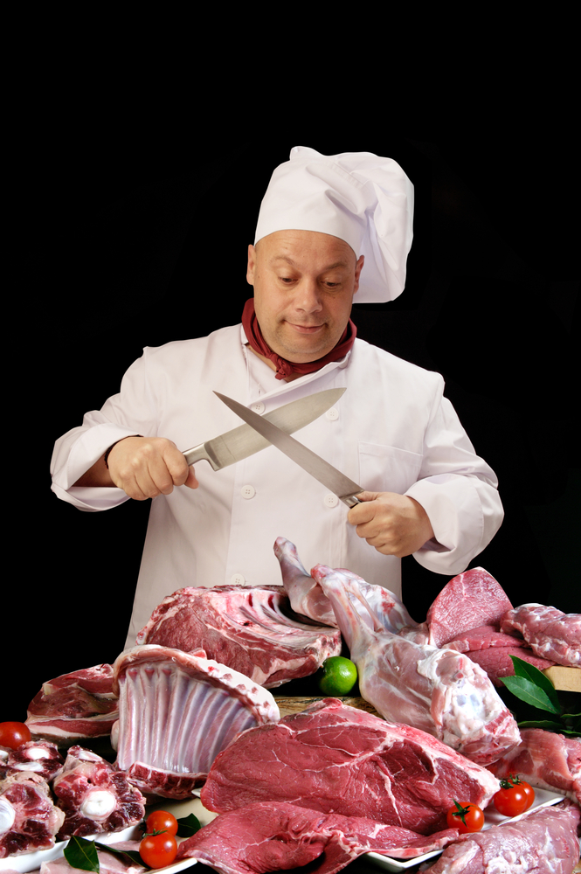
Not all off-cuts will be usable
- Off cuts of vegetable can be used in vegetable stocks
- Off cuts of meats may be saved and utilised in other meat dishes but it has to be economically viable to do this.
Products that have been frozen and thawed cannot be refrozen so it can be used in another dish at another time.
It can be unviable to save small amounts of meat to use in another dish. Chef of the kitchen will have to make that decision.
It is good practice to utilise any off cut into other usable dishes where a return to the kitchen can be claimed.

2.2 Dispose of food wastage in line with enterprise and local authorities’ requirements

Introduction
Everyone working in the hospitality and tourism industries is expected to comply with the relevant environmental regulations and requirements that apply to their workplace.
Compliance can and will vary between workplaces – a venue selling fast food in a capital city is likely to face a different raft of compliance issues to a resort in the wilderness or on an island.

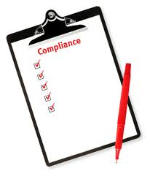
What compliance requirements might apply?
In general terms, compliance might include:
- Meeting relevant federal, state or territory laws
- Meeting local government laws, by-laws and regulations as they apply to local council areas
- Meeting the requirements of industry codes of practice/conduct as they apply to associations to which the business belongs or subscribes
- Meeting the compulsory standards and requirements that apply to an industry accreditation scheme to which the business has decided to belong.
You are advised the notes in this section are intended to be generic only in terms of identifying issues that a business may have to comply with.
All readers must undertake additional appropriate research to determine exactly what applies to them in terms of their individual circumstances in terms of:
- Business type
- Physical location of the business
- Size of the operation
- Activities being undertaken and resources being used
- Time – environmental legislation is subject to regular change and new laws (and interpretations and definitions) are being introduced over time.

Context
Ensuring the sustainability of the environment for human habitation and preserving scarce resources is now a global concern, and is increasingly becoming a factor in quantifying well-being.
Students need to be aware of the environmental of their Local Government Authorities and these should mirror National standards.

Local government laws
Your local Council also plays a significant role in environmental issues especially those applying to noise, pollution and waste disposal.
The laws established by the local Council will support and supplement state and federal legislation and factor in issues relevant to their local communities and situations.
To identify what your local council requires:
- Visit their website
- Call in person to the local Council and speak to an officer.

The basic legal requirements
In essence (and you will need to obtain information from your local authorities to determine the details) a business is required to:
- Refrain from air pollution
- Refrain from water pollution
- Refrain from causing contamination or damage to the land, flora and fauna
- Limit the noise it produces – including noise occasioned from music, noise made by patrons leaving the premises etc.
- Dispose of its waste correctly.
Local Authorities will have might have regular collection of waste material or the local government may expect enterprise to pay for their waste products to be taken away and disposed of in a fit and proper method.

Environmental Codes of Practice
Establishments may also subscribe to an industry code of practice detailing the actions they will, and will not, take in relation to environmental issues.
Adherence to a Code of Practice is not legally required (or binding) but ongoing membership of, say, an industry body may require you abide by the code they publicly proclaim and promote.
A Code of Practice may also be referred to as a Code of Conduct or some other similar term. The Code is a list of statements made by the industry body on behalf of its members stating the actions and standards they will achieve or strive to attain.
The statements in the Code are developed by members of the group and ratified by the membership.
By making these statements and requiring their member organisations comply with those requirements, the Code gives members of the public confidence in the body and its members and demonstrates their commitment to environmental sustainability.
Environmental values and human activities (beneficial uses) that need protection from the effect of pollution and waste, such as:
- Human health and well-being
- Ecosystem protection
- Visibility
- Useful life and aesthetic appearance of buildings, structures, property and materials
- Aesthetic enjoyment and local amenity.

2.3 Process recyclable products to local authority requirements
All food products used in commercial kitchens will come in some sort of container.
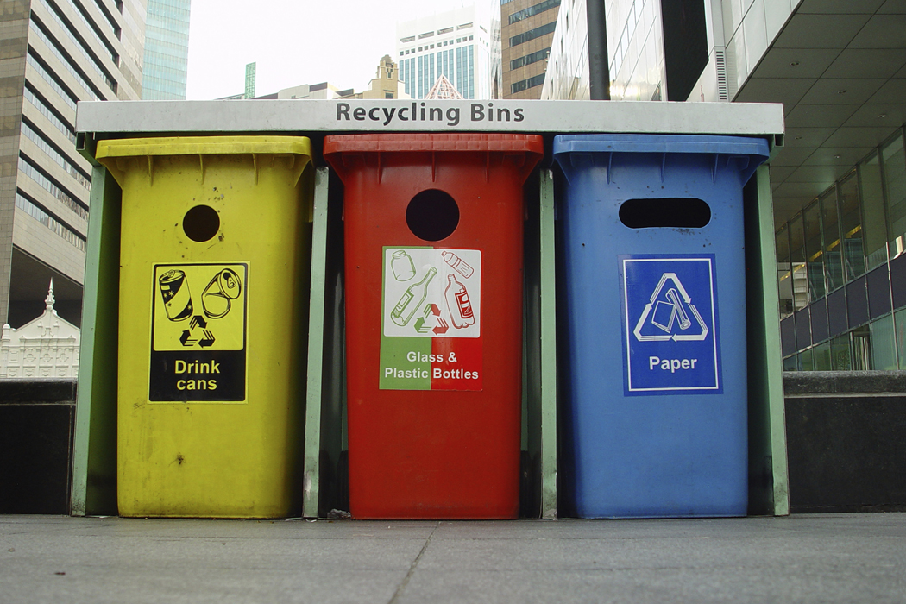
- Glass
- Plastics
- Paper, cardboard
- Metal.
Most of these products can be recycled and this will reduce the amount of rubbish and waste that goes into landfill.
The biggest pollutant is plastics as it does not break down in the landfill.
‘Breaking down’ is the term used to describe the action of the microbes that live in the soil consuming the edible matter and passing the waste out of their body as excrement.
This is what happens with food scraps that go into the landfill. Microbes come and eat the food.
Paper and cardboard products get wet and that makes them edible by the microbes in the soil. Waxed cardboard cannot be placed into landfill; it must be disposed of separately
No metal products should go into rubbish. It must be separated and sent to special recycling companies that will re-use the metal in other products.
- Glass receptacles need to be cleaned and sent to a glass recycling depot
- Plastic containers need to be cleaned and sent to a plastic recycling depot.
All these recycling depots will be operating in larger cities and smaller townships.
Other waste products:
Cooking oil
Cooking oil that is taken from deep fryers and woks should never be placed into the rubbish bin. All fats must go into separate recycling bins so it can be re-used into other products.
Food scraps
Food scraps will go into rubbish bins. Some local government authorities will have a place so that food scraps can be turned into compost products before it is placed back onto the market as fertiliser.
If food scraps are just thrown out onto the ground surface it will attracts vermin like wild animals, rats and mice. It is important that no rubbish is left lying around to attract unwanted pests.
All waste must be disposed of in a safe and efficient manner under the directive of Local Government Authorities.

Work Projects
It is a requirement of this Unit you complete Work Projects as advised by your Trainer.
You must submit documentation, suitable evidence or other relevant proof of completion of the project by the date agreed with your Trainer.
Your Trainer will clarify this more but all this will be adding you’re your own database of knowledge.
The student will need to show competency in the following criteria to be deemed competent.
Students will need to complete a series of exercises that will show competency.
A report outlining the following criteria:
2.1 Use food trimmings in a viable manner:
- How will food trimming be utilised in the kitchen?
2.2. Dispose of waste and recyclable materials.
- What are the waste disposal methods of your enterprise?
- Do these methods comply with the requirements of the local government authority?
- What are the costs related to these disposal methods?
- What are the recycling requirements of the local government authorities?

Summary

Minimise wastage
Use trimmings of food products
Any usable trimmings should be utilised in other dishes where viable to do so
Vegetable trimmings into stocks or soups
Meat trimmings in to other meat dishes
Anything that does not compromise the safety of the food for human consumption
If the process takes more time than what the value of the resource retrieved then the trimmings are best disposed off.
Dispose of food wastage in line with enterprise and local authorities’ requirements
All catering enterprises will have refuse, garbage, rubbish that needs to be disposed of in a responsible manner.
Local governments will inform each enterprise of the requirement for their area.
Best practice is to separate organic and non organic
Non organic is further separated between paper, glass, plastic and metals
Non organic is product that will not break down when it is placed into land fill
Organic will decompose, breakdown, when it is placed into landfill.
Process recyclable products to local authority requirements
Recycle all products that can be recycled.
Paper
Plastic
Glass
Metals.
All need to be separated and disposed of separately. How this is handled is under the control of the local government authority.
Some of this can be managed by the local community but this alone is not sufficient.

Presentation of written work

1. Introduction
It is important for students to present carefully prepared written work. Written presentation in industry must be professional in appearance and accurate in content. If students develop good writing skills whilst studying, they are able to easily transfer those skills to the workplace.

2. Style

Students should write in a style that is simple and concise. Short sentences and paragraphs are easier to read and understand. It helps to write a plan and at least one draft of the written work so that the final product will be well organised. The points presented will then follow a logical sequence and be relevant. Students should frequently refer to the question asked, to keep ‘on track’. Teachers recognise and are critical of work that does not answer the question, or is ‘padded’ with irrelevant material. In summary, remember to:
- Plan ahead
- Be clear and concise
- Answer the question
- Proofread the final draft.

3. Presenting Written Work
Types of written work
Students may be asked to write:
- Short and long reports
- Essays
- Records of interviews
- Questionnaires
- Business letters
- Resumes.
Format
All written work should be presented on A4 paper, single-sided with a left-hand margin. If work is word-processed, one-and-a-half or double spacing should be used. Handwritten work must be legible and should also be well spaced to allow for ease of reading. New paragraphs should not be indented but should be separated by a space. Pages must be numbered. If headings are also to be numbered, students should use a logical and sequential system of numbering.
Cover Sheet
All written work should be submitted with a cover sheet stapled to the front that contains:
- The student’s name and student number
- The name of the class/unit
- The due date of the work
- The title of the work
- The teacher’s name
- A signed declaration that the work does not involve plagiarism.
Keeping a Copy
Students must keep a copy of the written work in case it is lost. This rarely happens but it can be disastrous if a copy has not been kept.
Inclusive language
This means language that includes every section of the population. For instance, if a student were to write ‘A nurse is responsible for the patients in her care at all times’ it would be implying that all nurses are female and would be excluding male nurses.
Examples of appropriate language are shown on the right:
Mankind | Humankind
Barman/maid | Bar attendant
Host/hostess | Host
Waiter/waitress | Waiter or waiting staff

Recommended reading
Cracknell.H,

Kaufmann.R; 2009 (3rd edition); Practical Professional Cookery; Cengage Learning
Dodgshun. Graham,Peters.M; 2012 (6th edition);Cookery for the Hospitality Industry; Cambridge University Press
Drysdale.John; 2008 (4th edition); Profitable Menu Planning; Prentice Hall
Graham Dark, Deirdre McLean & Sarah Weatherhead; 2011 (2nd edition); Kitchen Operations; Pearson Australia
Gregoire, Mary B; 2013 (8th edition); Foodservice organisations: a managerial and systems approach; Pearson
Feinstein. Andrew H, Stefanelli. John M; 2009 (2nd edition); Purchasing for Chefs: A Concise Guide; Wiley
Leonard.E; 2011; Modern Buffets: Blueprint for Success;Wiley
McLean.D,Satori.l, Walsh C&S; 2004;The Professional Cook’s book: Commercial Cookery; Tertiary Press
McVety.P, Ware.B, Ware.C; 2

008 (3rd edition); Fundamentals of Menu Planning; Wiley
McWilliams, Margaret; 2013 (10th edition); Food fundamentals; Pearson
National Restaurant Association; (2006, 6th edition); ServSafe Manager; Prentice Hall
Scanlon.N; 2012 (4th edition); Catering Management; Wiley
The Culinary Institute of America (CIA); 2011 (9th edition); The Professional Chef; Wiley
Traster.Daniel; 2013; Foundations of Menu Planning; Prentice Hall
Waters.D; 2003 (2nd edition); Inventory Control and Management; Wiley

Trainee evaluation sheet

Apply catering control principles and procedures
The following statements are about the competency you have just completed.
Please tick the appropriate box | Agree | Don’t Know | Do Not Agree | Does Not Apply
There was too much in this competency to cover without rushing.
Most of the competency seemed relevant to me.
The competency was at the right level for me.
I got enough help from my trainer.
The amount of activities was sufficient.
The competency allowed me to use my own initiative.
My training was well-organised.
My trainer had time to answer my questions.
I understood how I was going to be assessed.
I was given enough time to practice.
My trainer feedback was useful.
Enough equipment was available and it worked well.
The activities were too hard for me.

The best things about this unit were:

The worst things about this unit were:

The things you should change in this unit are:

Trainee Self-Assessment Checklist
As an indicator to your Trainer/Assessor of your readiness for assessment in this unit please complete the following and hand to your Trainer/Assessor.

Apply catering control principles and procedures
 |  | Yes | No*
Element 1: Apply catering control principles and procedures
1.1 | Identify the range of catering products used within the enterprise
1.2 | Use requisition/portion control effectively
1.3 | Use standard recipes correctly
1.4 | Implement ordering and stock rotation practices
1.5 | Use optimum storage conditions
Element 2: Minimise wastage
2.1 | Use trimmings of food products
2.2 | Dispose of food wastage in line with enterprise and local authorities’ requirements
2.3 | Process recyclable products to local authority requirements

Statement by Trainee:
I believe I am ready to be assessed on the following as indicated above:
Signed: | _____________________________ | Date: | ______ / ______ / ______
Note:
For all boxes where a No* is ticked, please provide details of the extra steps or work you need to do to become ready for assessment.





